Ansonia High School Tigers Football 2019
Jersey # Name Position Grade
2 Ian Schmitmeyer QB/DB Fr.
3 Kayden Edwards SE/LB Fr.
4 Hunter Buckingham** QB/DB Sr.
5 Ethan Fischer** RB/DB Sr.
7 Reece Stammen** RB/LB Jr.
9 Alliyah Hall K Fr.
10/70 Ethan Setser** TE/LB Sr.
12 Kolton Young RB/DB So.
14 Isaac Barga** SE/LB Jr.
15 Jackson Shellhaas RB/DB So.
21 Dustin Burk RB/DB So
22 Peyton Beam RB/LB So.
23 Brock Shellhaas** RB/DB Sr.
24 Ethan Hemmerich SE/LB Jr.
25 Maverick Widener SE/LB Jr.
28 Exzavier Moody RB/LB Fr.
36 Gabe Zumbrun RB/LB Fr.
40 Ean McKee TE/LB Jr.
50 Tytus Gasper OL/DL So.
52 Preston Prater OL/DL Jr.
53 Jason Stover OL/DL Fr.
55 Trevor Martin OL/DL Sr.
58 Cameron Prater OL/DL Jr.
60 Zach Ward OL/DL Jr.
63 Levi Gasper OL/DL Fr.
65 Austin Ingle OL/DL Fr.
72 Austin Helmke** OL/DL Sr.
75 Eyan Hackler OL/DL Fr.
79 Yukon Riffell OL/DL Fr.

**Returning Letter Winner

Cheerleaders: Julie Oswalt, Sr., Alexis Morrison, So., Lauren Burns, So., Cierra Rosinski, So., Lilian Billenstein, So., Kaylin Johnson, Fr., Madison Esser, Fr., Heavenly Shilt, Fr., Ariya Wickham, Fr., Kelsey Holden, Mercedes Geesaman

Head Varsity Coach: Matt Macy
Assistant Coaches: TJ Phlipot, Stuart Beisner, Adam Hall, Eric Grilliot, Kyle Homan, Mason Thobe, Kenny Edwards
Head Cheer Advisor: Kami Phlipot
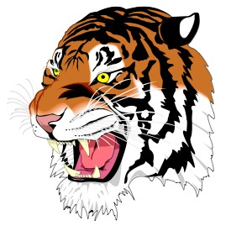
Videographer: Mike Osterloh

Ansonia High School
Jim Atchley-Superintendent
Jim Robson- Principal
Matt Macy-Athletic Director
Athletic Trainer- Kurt Moneysmith (Wayne Health)

