Ansonia High School Tigers Football 2019
Jersey # Name Position Grade
2 Ian Schmitmeyer QB/DB Fr.
3 Kayden Edwards SE/LB Fr.
4 Hunter Buckingham** QB/DB Sr.
5 Ethan Fischer** RB/DB Sr.
7 Reece Stammen** RB/LB Jr.
9 Alliyah Hall K Fr.
10 Ethan Setser** TE/LB Sr.
12 Kolton Young RB/DB So.
14 Isaac Barga** SE/LB Jr.
15 Jackson Shellhaas RB/DB So.
21 Dustin Burk RB/DB So
22 Peyton Beam RB/LB So.
23 Brock Shellhaas** RB/DB Sr.
24 Ethan Hemmerich SE/LB Jr.
28 Exzavier Moody RB/LB Fr.
36 Gabe Zumbrun RB/LB Fr.
40 Ean McKee TE/LB Jr.
50 Tytus Gasper OL/DL So.
52 Preston Prater OL/DL Jr.
53 Jason Stover OL/DL Fr.
55 Trevor Martin OL/DL Sr.
58 Cameron Prater OL/DL Jr.
60 Zach Ward OL/DL Jr.
63 Levi Gasper OL/DL Fr.
65 Austin Ingle OL/DL Fr.
72 Austin Helmke** OL/DL Sr.
75 Eyan Hackler OL/DL Fr.

**Returning Letter Winner

Cheerleaders:

Head Varsity Coach: Matt Macy
Assistant Coaches: TJ Phlipot, Stuart Beisner, Adam Hall, Eric Grilliot, Kyle Homan, Mason Thobe, Kenny Edwards
Head Cheer Advisor: Kami Phlipot
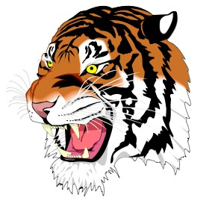
Videographer: Mike Osterloh

Ansonia High School
Jim Atchley-Superintendent
Jim Robson- Principal
Matt Macy-Athletic Director
Athletic Trainer- Kurt Moneysmith (Wayne Health)

