Ansonia High School Tigers Football 2018
Jersey # Name Height Weight Position Grade
2 Devyn Sink* 5’10 185 RB/DL Sr.
3 Jackson Shellhaas 5’5 105 RB/DB Fr.
4 Hunter Buckingham* 5’10 155 QB/DB Jr.
5 Ethan Fischer* 5’9 150 RB/DB Jr.
7 Reece Stammen* 5’10 200 RB/LB So.
8 Jacob Longenecker 5’9 140 SE/DB So.
9 Dustin Burk 5’1 95 RB/DB Fr.
10 Ethan Setser 6’1 165 TE/LB Jr.
11 Michael Hall* 5’10 140 K Sr.
14 Isaac Barga 5’8 150 QB/DB So.
15 Matthew Shook* 6’0 165 RB/DB Sr.
22 Peyton Beam 5’10 180 RB/LB Fr.
23 Brock Shellhaas* 5’11 165 RB/DB Jr.
27 Hunter Muir* 6’5 190 SE/LB Sr.
32 Jeremy Rismiller 5’10 172 TE/LB Sr.
40 Ean McKee 5’11 190 TE/DL So.
50 Tytus Gasper 5’7 165 OL/DL Fr.
51 Jedd Rismiller 6’0 200 OL/DL Sr.
55 Dillon Hackler 5’6 145 OL/DL So.
60 Zach Ward 5’9 220 OL/DL So.
71 Ross Shook* 5’10 230 OL/DL Sr.
72 Austin Helmke* 5’11 245 OL/DL Jr.
75 Andrew Rowland* 5’10 215 OL/LB Sr.
76 Peyton Setser* 6’6 195 OL/LB Sr.

*Returning Letter Winner

Cheerleaders: Kiley Grilliot (Sr.), Abigail Powers (Jr.), Julie Oswalt (Jr.), Kassie Weyant (So.), Neleh Schlarman (Fr.), Alexis Morrison (Fr.), Cierra Rosinski (Fr.), Ellie Pierre (Fr.), Lauren Burns (Fr.), Lilian Billenstein (Fr.)

Head Varsity Coach: Eugene Hoening
Assistant Coaches: TJ Phlipot, Stuart Beisner, Adam Hall, Matt Macy, Eric Grilliot, Kyle Homan, Mason Thobe, Kenny Edwards
Head Cheer Advisor: Kami Phlipot
Assistant Cheer Advisor: Lexi Shinn
Videographer: Mike Osterloh

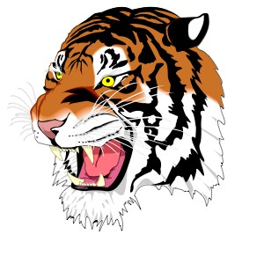

Ansonia High School
Jim Atchley-Superintendent
Jim Robson- Principal
Matt Macy-Athletic Director
Athletic Trainer- Kurt Moneysmith (Wayne Health)

